ByteScout Barcode Generator

Steps for running the ByteScout Barcode Generator:

1. Locate the “**BarCodeGenerator.exe**” on the Desktop
2. Double click on the “**BarCodeGenerator.exe**” to start the program.
3. 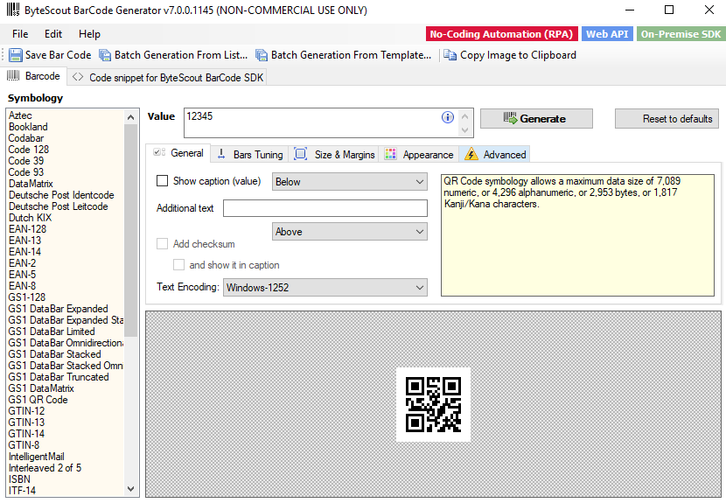Confirm what is shown on your screen matches what is in *Figure 7-1*.

*Figure 7-1*

*Figure 7-1*

# Creating a QR Code / Barcode in Barcode Generator

1. Select the “**QR code**” or “**PDF417**” (barcode) option from the Symbology list.
2. Input into the **Value** textbox a series of letters and numbers with a minimum of 12 to 24 characters.
3. Click “**Generate**” to create your unique QR code or barcode.
4. Click “**Save Bar Code**”
5. Choose a destination to store your QR code or barcode.
6. Print QR codes or barcodes via word document or photos.

**4**

**1**

**2**

**3**

*Figure 7-2*

# Creating Multiple Barcodes / QR Code in Barcode Generator

1. Select the “**QR code**” or “**PDF417**” (barcode) option from the Symbology list.
2. Click “**Batch Generation from List…”** to create multiple barcodes / QR codes.
3. Input into the **Value** textbox a series of letters and numbers with a minimum length of 12 to 24 characters.
4. Click “**Generate multiple barcodes**” to create your unique barcodes / QR codes.
5. Choose a destination to store your QR code or barcodes.
6. Print QR codes or barcodes via word document or photos.

**2**

**1**

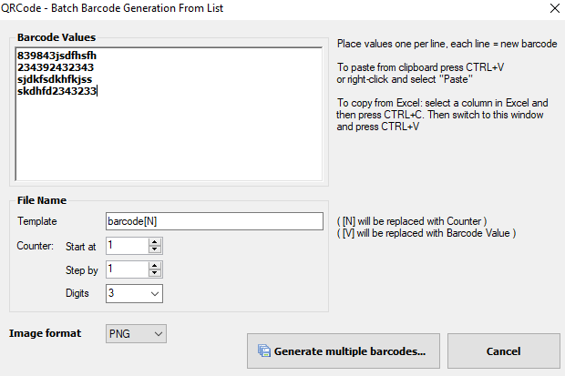

**3**

*Figure 7-3*

**4**

*Figure 7-4*

8